**Get request using GitHub**:

First create a token in GitHub for that go to profile select settings select developers settings in that classic Api as shown in below

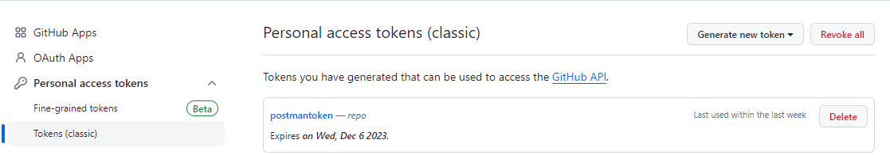

After generating the key copy the key and open postman the Api for the git hub is given below

<https://api.github.com/user/repos>

And Get the Url and in Authorize section add the key as bearer token as given below

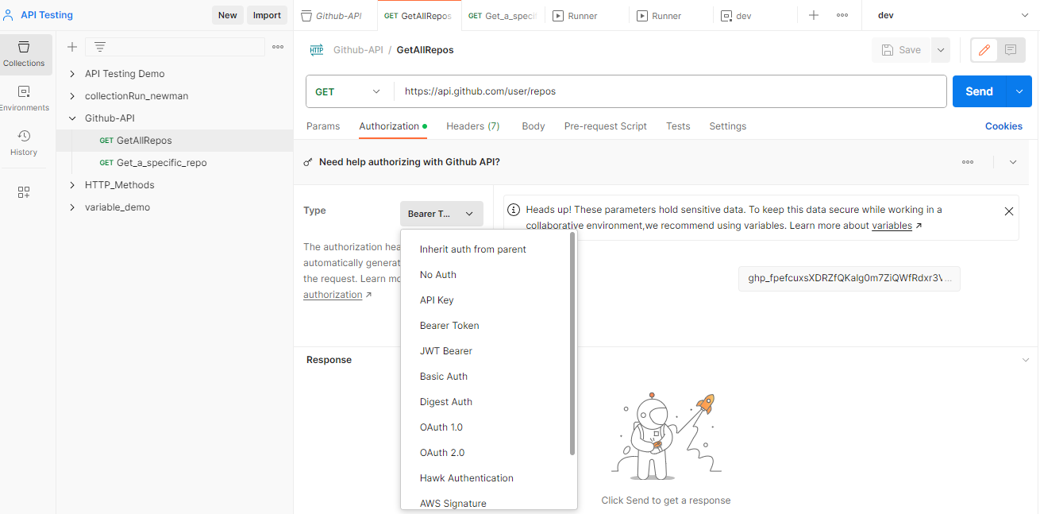

After send the request we get the below result

